**Introduction:**

This document contains brief introduction of the working of the stimuli generated in Leuven.

**Noise Stimuli:**

**ARMIN:**

ARMIN is a binaural stimulus. In one of the channels, the signal is correlated with the other channel until a certain frequency, and then it ‘flips’, that is it becomes inversely correlated. The frequency at which this inversion takes place is called Flip Frequency (Ff). The Ff is varied in steps as per the (flip) frequency stepper panel.

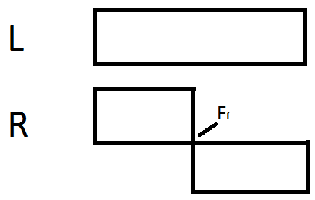

(Please forgive the crude drawing)

**BPN:**

BPN (Band Pass Noise) is a signal that generates a full bandwidth noise in the first instance, and in the following instances it acts as a bandpass filter. The lower or higher edge (Cutoff Frequency) can be varied while keeping the other edge constant. This variation takes place in steps as per the data in the Cutoff Frequency Panel.

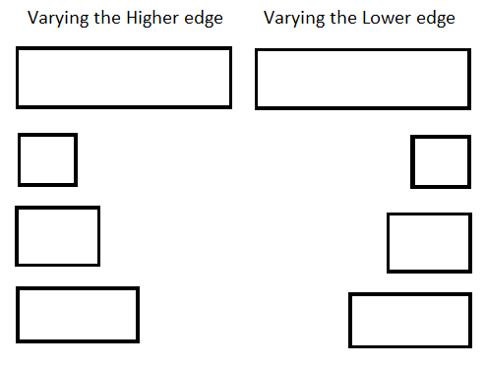

**Other Helper Functions:**

* stimdef – defines the stimulus and creates its panels
  + ParamQuery – used in GUI; sets the name, prompt, units, tooltip, etc.
  + Summary() – creates the summary pannel
* FrequencyStepper – generates the frequency increments
* EvalFrequencyStepper – evaluates the frequencies from the textbox and checks for their validity
  + (Similar functions: EvalNoisePanel, EvalDurPanel, and EvalPresentationPanel)
* NoisePanel – as the name suggests, creates a Noise generation panel
  + (Similar functions: DurPanel and PresentationPanel)
* NoiseStim – this is where the magic happens: the noise is generated in this function
  + NoiseSpec – generates a spectral noise buffer which is used in NoiseStim
  + ExactGate – gates the generated signal
  + Samplerate – each speaker has its own sampling rate. This function selects the minimum sampling rate in accordance to the Nyquist theorem.
* ReportSummary – displays the data of the generated waveform in the summary panel
* StimCheck – checks for the working of the stimulus
* GUIval – evaluates the GUI data and creates objects with user inputs
  + getGUIdata – self-explanatory

Update Log:

1. Gowtham – 28/06/2019 – Intro to ARMIN and BPN, Other helper functions